

Hi there.

Were currently practicing social distancing for Covid-19.

Help us out, by sanitizing and following the instructions for assistance

Press on the “Press” icon located on the phone and wait

A team member will be with your shortly.  
If you would prefer to use your own phone call 555-1234

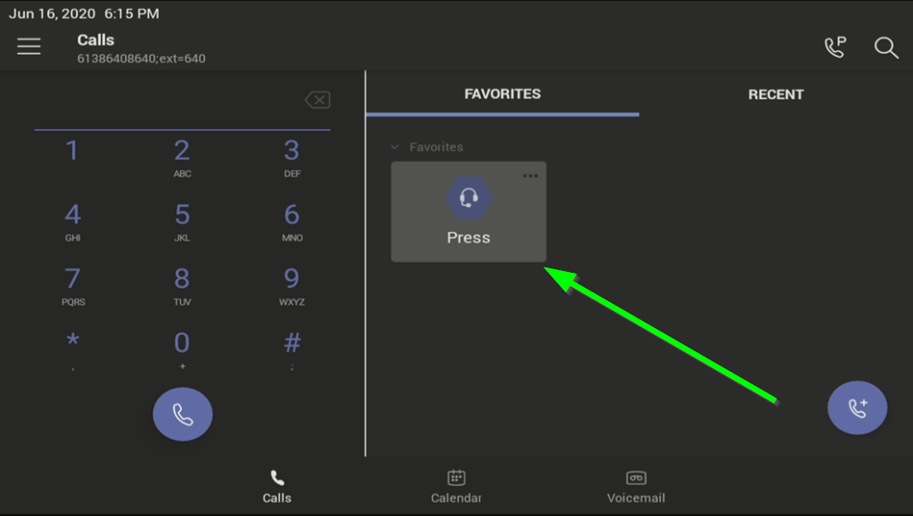

Call us

Use Video

Once the call is answered, Press the Camera Icon 

to turn video on so we can see each other!

None of this video is saved or recorded, thanks for your understanding